Audio Library ASP.Net Core Project

Samuel Bailey
2025
Contents
1 Project Overview 2
2 Architecture Diagram 2
3 Technology Stack 2
4 Design Patterns 2
4.1 MVC Architecture 2
4.2 Data Model Details 2
4.3 Wireframe Page (UI) Designs 2
4.4 User Experience (UX) Workflows 3
5 API Design 3
6 Data Model 3
7 Deployment Strategy 3
8 Appendix 3
8.1 Packages Used 3
8.2 References 3

Project Overview
This section provides a high-level overview of the ASP.NET Core solution, including its purpose, scope, and key features.
Purpose:
RecordShelf is a web-based application designed to allow users to manage and post their audio recordings, either for podcasts or music projects. The app supports CRUD operations (Create, Read, Update, Delete) on audio posts stored in a MongoDB NoSQL database. It also features categorization, search, and tagging capabilities. Users finally will be able to play their audio files from the browser.
Features:
- User registration and authentication
- Add, edit, delete, and view posts
- Categorize and tag recordings
- Search and filter by title, artist, or tags
- Play recordings

Architecture Diagram
Insert architecture diagram here illustrating the ASP.NET Core API, Web projects, and MongoDB backend.
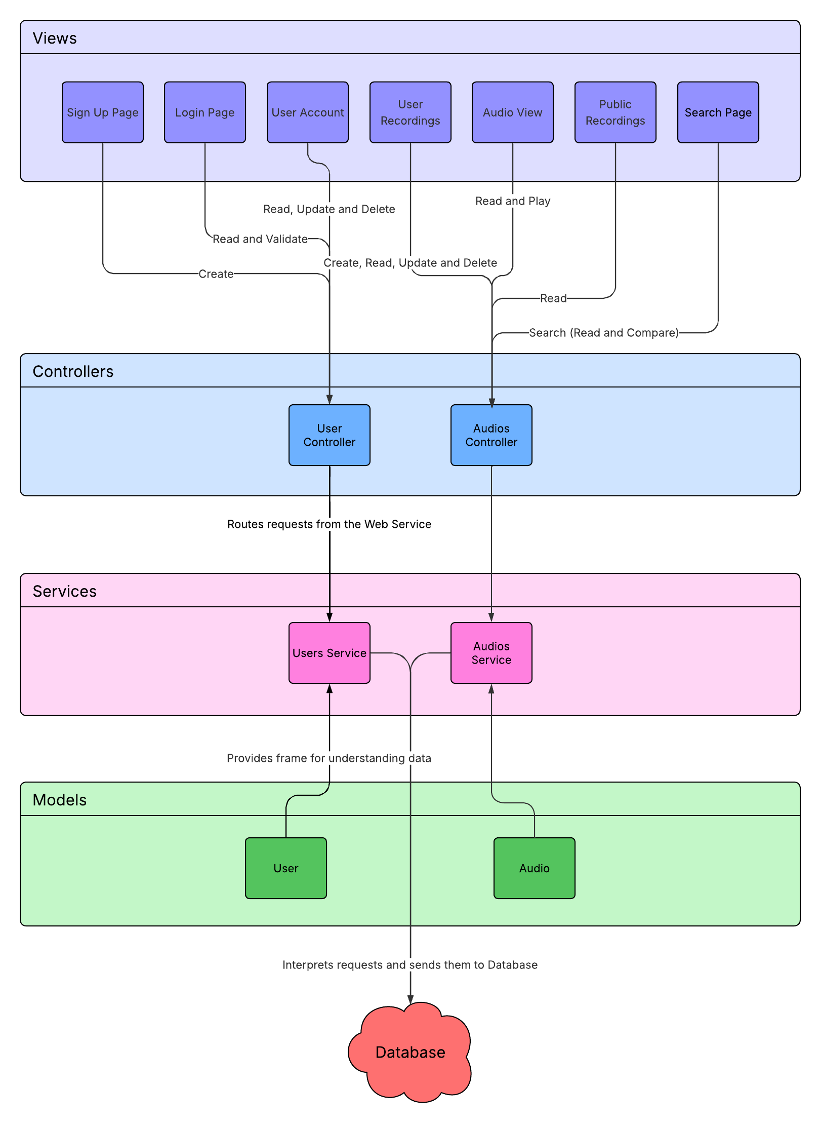

Technology Stack
- ASP.NET Core
- MongoDB
- ASP.NET Core Web API
- ASP.NET Core MVC
- C#
- Visual Studio
- Docker (optional for deployment)

Design Patterns
This section outlines the design patterns used in the solution, including MVC architecture, data modeling, UI wireframes, and UX workflows.

MVC Architecture
The solution follows the Model-View-Controller (MVC) design pattern. The API project handles the controller logic and data access, while the Web project manages the views and user interactions.
- Model
- User: This model determines the attributes that a user will have.
- Audio: This model determines the attributes that an audio will have.
- Analytics: This model is for collecting the analytics of audio views.
- View
- Sign Up Page: This view will be able to send requests to Create new User entities.
- Log In Page: This view will Read the User entities held and validate someone’s login details against their User attributes to let them log in.
- Account Page: This account settings page will allow Users to edit their details with an Update request and delete their account/User entity should they wish.
- User Recordings/Projects Page: This page allows Users to upload new audios with a Create API. You can also edit and delete posted audios with the Update and Delete APIs
- Audio View Page: This page allows viewers to listen to the audios, with a Read function API.
- Public Search Page: This page allows viewers to view all posted public audios from users.
- Controller
- User Controller: This class determines how requests for User entities will be parsed. It will hold the Create, Read, Update and Delete methods for Users.
- Audio Controller: This class determines how requests for Audio entities will be parsed. It will hold the Create, Read, Update and Delete methods for them.

Data Model Details
The backend uses MongoDB to store data in collections. Each collection represents a domain entity. Relationships are modeled using embedded documents or references.
- Users Collection: Stores user profiles and authentication details.
- Audios Collection: Contains audio information, location and metadata.
- Analytics Collection: Tracks user listens and audio listens.
- Relationships: Analytics reference Users and Audios using UserID and AudioID fields.

Wireframe Page (UI) Designs
Wireframes represent the layout of key pages in the Web project. Placeholder descriptions:
- Sign Up Page:
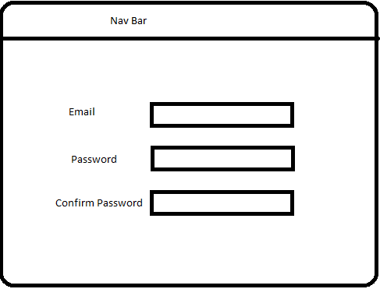

- Log In Page:
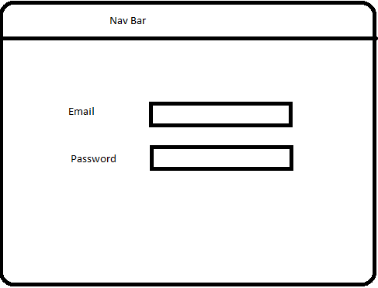
- Account Page:
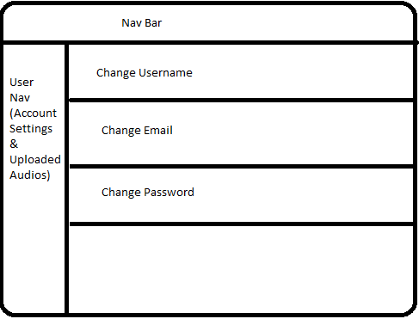

- User Home Page (User Recordings):
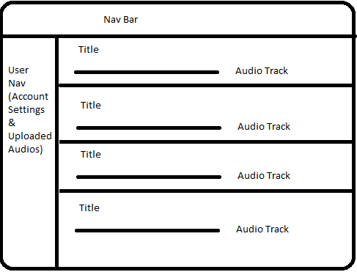
- Audio View Page:
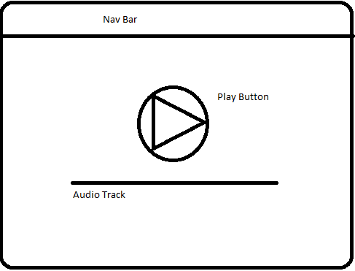

- Public Search Page:
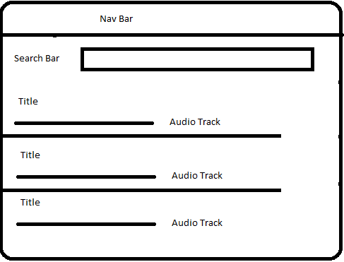

User Experience (UX) Workflows
User experience workflows describe the journey users take through the application.
- Registration Workflow: User signs up, receives confirmation email, logs in.
- Upload Workflow: User uploads audio file, names and tags it, decides if it’s private or public.
- Search Workflow: User inputs search term, all matched Users and Audios are displayed, upon clicking audios can be played.

API Design
Describe the RESTful API endpoints, request/response formats, authentication mechanisms, and error handling strategies.
- /API/User/Create
- /API/User/Auth
- /API/User/Update{email}
- /API/User/Update{password}
- /API/User/Update{username}
- /API/User/Delete
- /API/User/ListAll
- /API/User/ListDetails

- /API/Audio/Upload
- /API/Audio/Update
- /API/Audio/ListAll
- /API/Audio/ListDetails
- /API/Audio/Play
- /API/Audio/Delete

- /API/Analytics/List

Data Model
Define the MongoDB collections and document structure. Include relationships and indexing strategies.
[User]
- UserID (PK)
- Name
- Email
- Password

[Audio]
- AudioID (PK)
- Name
- UserID
- Artist
- Tags
- DurationSeconds
- FilePath
- UploadDate

[Analytics]
- Analytics (PK)
- ListenCount
- LikeCount
- UserID
- AudioID

Relationships
Relationship: User (1) —— (∞) Audio
Relationship: User (1) —— (∞) Analytics
Relationship: Audio (1) —— (1) Analytics

Deployment Strategy
Outline the deployment process including environment setup, CI/CD pipeline, and hosting options (e.g., Azure, AWS, Docker).
Blue Green Deployment
- The latest version is run and tested before a switch it made to redirect the traffic to the deployed green/new version of the web app, from the blue/old version of the app.
- This will be hosted on AWS as TAFE Students get some amount of free usage of this system.

Appendix

Packages Used
Details packages used in project. Include description of package and reasoning for including package.

References
Using APA7 Referencing, include any relevant sources used to help develop/design your project.

